Practical 5:- MongoDB Integration and Schema Design with Mongoose
Objective: | To connect a MongoDB database to an Express server and enforce data validation through Mongoose schema.
Problem Statement: | • Extend the Task Management backend from Practical 4 by connecting MongoDB using Mongoose.  • Define a Task schema with at least 4 fields: title (String, required), description (String), completed (Boolean, default false), createdAt (Date, default Date.now).  • Replace the in-memory array from Practical 4 with real Mongoose model operations.  • Test all CRUD operations against the live database using Postman.  • Ensure validation errors are returned as structured JSON, not raw Mongoose error objects.
Implementation | Task Card:  import { FiClock, FiEdit2, FiTrash2 } from 'react-icons/fi';  import { formatDueDate } from '../utils/format.js';  import {  cn,  paperCard,  gloss,  paperCardLift,  badge,  badgeGreen,  badgeYellow,  badgeRed,  badgeBlue,  statusDot,  btnIcon,  btnIconDanger,  notebookAccent,  accentHigh,  accentMedium,  accentLow,  } from '../styles/classes.js';  const STATUS_META = {  pending: { label: 'Pending', badge: badgeYellow, dot: 'bg-status-yellow' },  in_progress: { label: 'In Progress', badge: badgeBlue, dot: 'bg-status-blue' },  completed: { label: 'Completed', badge: badgeGreen, dot: 'bg-status-green' },  };  const PRIORITY_META = {  high: { label: 'High', badge: badgeRed, accent: accentHigh },  medium: { label: 'Medium', badge: badgeYellow, accent: accentMedium },  low: { label: 'Low', badge: badgeGreen, accent: accentLow },  };  const isOverdue = (task) => {  if (task.status === 'completed' || !task.dueDate) return false;  const due = new Date(`${task.dueDate}T00:00:00`);  const today = new Date();  today.setHours(0, 0, 0, 0);  return !Number.isNaN(due.getTime()) && due < today;  };  const TaskCard = ({ task, onEdit, onDelete }) => {  const status = STATUS_META[task.status] || STATUS_META.pending;  const priority = PRIORITY_META[task.priority] || PRIORITY_META.medium;  const isCompleted = task.status === 'completed';  const overdue = isOverdue(task);  return (  <article className={cn(paperCard, gloss, paperCardLift, 'flex h-full flex-col p-5')}>  {/* Colored priority spine */}  <span className={cn(notebookAccent, priority.accent)} aria-hidden="true" />  {/* Header: badges + actions */}  <div className="flex items-start justify-between gap-3">  <div className="flex flex-wrap items-center gap-1.5">  <span className={cn(badge, priority.badge)}>{priority.label}</span>  <span className={cn(badge, status.badge)}>{status.label}</span>  </div>  <div className="flex shrink-0 items-center gap-1">  <button  type="button"  className={btnIcon}  onClick={() => onEdit(task)}  aria-label={`Edit ${task.title}`}  >  <FiEdit2 />  </button>  <button  type="button"  className={cn(btnIcon, btnIconDanger)}  onClick={() => onDelete(task)}  aria-label={`Delete ${task.title}`}  >  <FiTrash2 />  </button>  </div>  </div>  {/* Title */}  <h3  className={cn(  'mt-3 line-clamp-2 text-base font-bold leading-snug',  isCompleted ? 'text-graphite-400 line-through' : 'text-graphite-800'  )}  >  {task.title}  </h3>  {/* Description — grows to fill the card so footers align */}  <p className="mt-1.5 line-clamp-2 flex-1 text-sm leading-relaxed text-graphite-500">  {task.description || 'No description provided.'}  </p>  {/* Footer: due date + status */}  <div className="mt-4 flex items-center justify-between border-t border-paper-200 pt-3">  <div  className={cn(  'flex items-center gap-1.5 text-xs font-medium',  overdue ? 'text-status-red' : 'text-graphite-500'  )}  >  <FiClock aria-hidden="true" />  <span>{formatDueDate(task.dueDate)}</span>  {overdue && (  <span className="ml-1 rounded-full bg-status-red/10 px-2 py-0.5 text-[10px] font-bold uppercase tracking-wide text-status-red">  Overdue  </span>  )}  </div>  <span className={cn(statusDot, status.dot)} title={`Status: ${status.label}`} />  </div>  </article>  );  };  export default TaskCard;  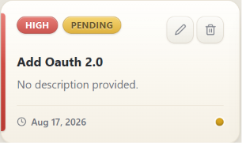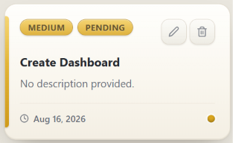  Dashboard  import { useMemo } from 'react';  import { useNavigate } from 'react-router-dom';  import {  FiActivity,  FiAlertTriangle,  FiCheckCircle,  FiClock,  FiLayers,  FiList,  FiPlus,  } from 'react-icons/fi';  import useTasks from '../hooks/useTasks.js';  import StatsCard from '../components/StatsCard.jsx';  import TaskCard from '../components/TaskCard.jsx';  import Button from '../components/Button.jsx';  import EmptyState from '../components/EmptyState.jsx';  import { cn, paperCard, gloss, emboss, statusDot } from '../styles/classes.js';  import { formatRelativeDate } from '../utils/format.js';  /** Small paper section header used across the page. */  const SectionHeader = ({ title, caption }) => (  <div className="flex items-end justify-between gap-3">  <div>  <h2 className={cn(emboss, 'font-display text-lg font-bold text-graphite-700')}>  {title}  </h2>  {caption && <p className="mt-0.5 text-xs text-graphite-400">{caption}</p>}  </div>  </div>  );  /** Quick actions card. */  const QuickActions = ({ onNewTask, onViewAll }) => (  <div className={cn(paperCard, gloss, 'relative p-5')}>  <h2 className={cn(emboss, 'font-display text-lg font-bold text-graphite-700')}>  Quick Actions  </h2>  <div className="mt-4 space-y-2.5">  <Button variant="primary" size="md" className="w-full" onClick={onNewTask}>  <FiPlus />  New Task  </Button>  <Button  variant="secondary"  size="md"  className="w-full"  onClick={onViewAll}  >  <FiList />  View All Tasks  </Button>  </div>  </div>  );  /** Recent activity feed derived from task history. */  const ActivityFeed = ({ items }) => (  <div className={cn(paperCard, gloss, 'relative p-5')}>  <h2 className={cn(emboss, 'font-display text-lg font-bold text-graphite-700')}>  Recent Activity  </h2>  {items.length === 0 ? (  <p className="mt-3 text-sm text-graphite-400">No activity yet.</p>  ) : (  <ul className="mt-4 space-y-4 border-l-2 border-accent-500/20 pl-4">  {items.map((item) => (  <li key={item.id} className="relative">  <span className={cn(statusDot, 'absolute -left-[21px] top-1.5 bg-status-blue')} />  <p className="text-sm font-semibold leading-snug text-graphite-700">  {item.title}  </p>  <p className="mt-0.5 text-xs text-graphite-400">  {item.status === 'completed' ? 'Completed' : 'Added'} ·{' '}  {formatRelativeDate(item.createdAt)}  </p>  </li>  ))}  </ul>  )}  </div>  );  /** Loading skeleton shown while the first fetch is in flight. */  const DashboardSkeleton = () => (  <div className="space-y-8">  <div className="grid grid-cols-1 gap-4 sm:grid-cols-2 xl:grid-cols-4">  {[0, 1, 2, 3].map((n) => (  <div key={n} className={cn(paperCard, 'h-36 animate-pulse')} />  ))}  </div>  <div className={cn(paperCard, 'h-64 animate-pulse')} />  </div>  );  /** Dashboard overview page. */  const Dashboard = () => {  const { tasks, loading, usingFallback } = useTasks();  const navigate = useNavigate();  const stats = useMemo(  () => ({  total: tasks.length,  completed: tasks.filter((task) => task.status === 'completed').length,  pending: tasks.filter((task) => task.status !== 'completed').length,  highPriority: tasks.filter((task) => task.priority === 'high').length,  }),  [tasks]  );  const recentTasks = useMemo(  () =>  [...tasks]  .sort((a, b) => new Date(b.createdAt) - new Date(a.createdAt))  .slice(0, 4),  [tasks]  );  const activity = useMemo(  () =>  [...tasks]  .sort((a, b) => new Date(b.createdAt) - new Date(a.createdAt))  .slice(0, 6),  [tasks]  );  if (loading) {  return <DashboardSkeleton />;  }  return (  <div className="space-y-8">  {/* Offline demo-mode banner */}  {usingFallback && (  <div className={cn(paperCard, 'flex items-center gap-3 border-accent-500/40 px-5 py-4')}>  <FiActivity className="shrink-0 text-accent-600" aria-hidden="true" />  <p className="text-sm text-graphite-600">  The API is not reachable — showing bundled demo data. Start the  backend (npm run dev in <code className="font-mono">backend</code>)  to use live data.  </p>  </div>  )}  {/* Statistics */}  <section  className="grid grid-cols-1 gap-4 sm:grid-cols-2 xl:grid-cols-4"  aria-label="Statistics"  >  <StatsCard  label="Total Tasks"  value={stats.total}  icon={<FiLayers />}  tone="blue"  subtitle="Across the workspace"  />  <StatsCard  label="Completed"  value={stats.completed}  icon={<FiCheckCircle />}  tone="green"  subtitle="Nice work, keep it up"  />  <StatsCard  label="Pending"  value={stats.pending}  icon={<FiClock />}  tone="yellow"  subtitle="Waiting for action"  />  <StatsCard  label="High Priority"  value={stats.highPriority}  icon={<FiAlertTriangle />}  tone="red"  subtitle="Needs attention soon"  />  </section>  {/* Content columns */}  <section className="grid grid-cols-1 gap-6 lg:grid-cols-3">  <div className="space-y-6 lg:col-span-2">  <SectionHeader  title="Recent Tasks"  caption="Most recently added tasks"  />  {recentTasks.length > 0 ? (  <div className="grid grid-cols-1 gap-4 md:grid-cols-2">  {recentTasks.map((task) => (  <TaskCard  key={task.id}  task={task}  onEdit={(selected) =>  navigate('/tasks', { state: { openModal: selected } })  }  onDelete={(selected) =>  navigate('/tasks', { state: { deleteTask: selected } })  }  />  ))}  </div>  ) : (  <EmptyState  icon={<FiLayers />}  title="No tasks yet"  message="Add your first task to see it here on the dashboard."  action={  <Button  onClick={() => navigate('/tasks', { state: { openModal: true } })}  >  <FiPlus />  Add Task  </Button>  }  />  )}  </div>  <aside className="space-y-6">  <QuickActions  onNewTask={() => navigate('/tasks', { state: { openModal: true } })}  onViewAll={() => navigate('/tasks')}  />  <ActivityFeed items={activity} />  </aside>  </section>  </div>  );  };  export default Dashboard;  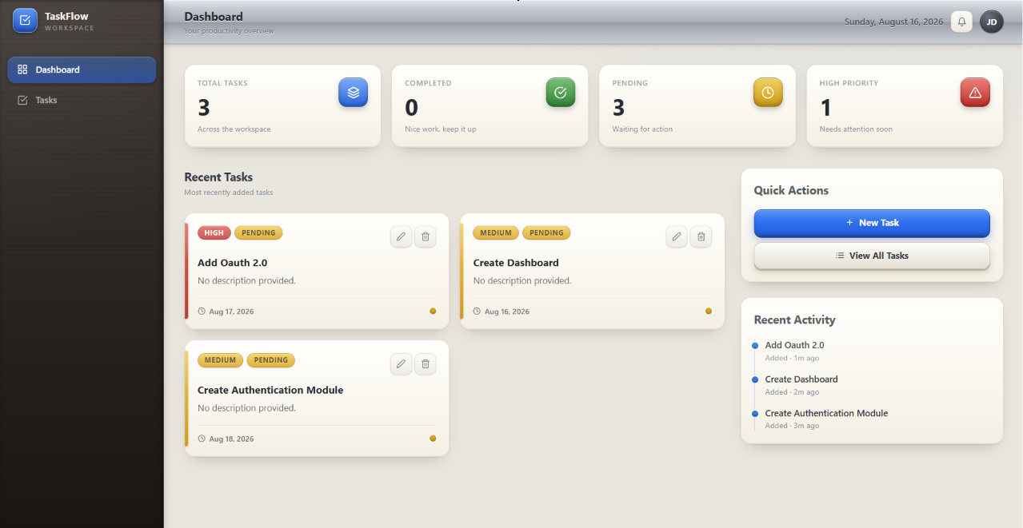  Database  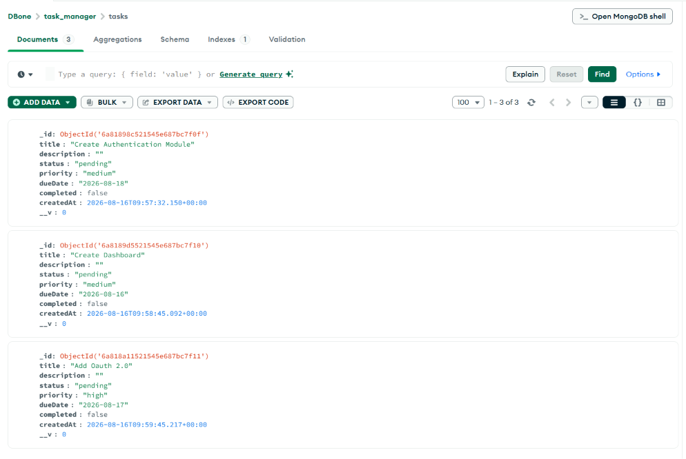
Outcome | Students will be able to connect an Express application to MongoDB using Mongoose, define a validated schema, and perform real CRUD operations against a live database.

